DMart Retail Analytics Project

Problem Statement
Retail organizations rely on accurate and interpretable revenue insights to support financial planning, performance evaluation, and strategic decision-making. However, transaction-level data often contains a mix of deterministic pricing components and limited behavioral signals, making it unclear whether predictive modeling can provide meaningful business value.
The primary problem addressed in this project is to evaluate how effectively historical retail transaction data can be used to analyze and forecast revenue, and to determine the appropriate analytical level (transaction-level vs aggregated-level) for reliable insights.
Objectives of the Analysis
The objectives of this project are to:
- Analyze historical transaction data to understand the key drivers of revenue
- Assess whether order-level revenue can be meaningfully modeled or is largely deterministic
- Evaluate the feasibility and usefulness of aggregated (monthly) revenue forecasting for financial planning
- Identify revenue patterns across regions, customer age groups, and product categories that can support strategic decisions
- Clearly distinguish between analytical insights that are feasible and predictive tasks that are not supported by the data
While operational aspects such as cancellations and payment mismatches were examined during exploratory analysis, the final scope of this study is intentionally focused on revenue analysis and forecasting, as these areas exhibit stronger analytical signal and align more closely with business planning requirements.

Contents
1.DATA DISCRITPION : 5
1.1. Dataset Overview 5
1.2. Column Descriptions 5
1.3. Key Insights for Documentation 7
1.4. Code-Based Data Audit 7
1.4.1: Checking Column Distribution 7
1.4.2: Statistical Summary of Key Measures 8
1.4.3: Null Value Analysis 8
1.5. Data Integrity Observations 8
2.Data Preparation (Excel Phase) 9
2.1. Data Auditing & Initial Cleaning 9
2.2. Feature Engineering in Excel 10
2.3. Financial Reconciliation & Logical Checks 10
2.4. Data Standardization (VLOOKUP / Replace) 11
2.5. Summary of Excel Preparations 11
3.Exploratory Data Analysis (EDA) : 12
3.1. Objective of EDA 12
3.2. Dataset Overview & Structure 13
3.3. Order Status Distribution 15
3.4. Payment Status vs Order Status 16
3.5. Revenue Distribution Analysis 17
3.6. Revenue by Product Category 18
3.7. Revenue by Subscription Type 19
3.8. Revenue by Region (State) 20
3.9. Discount Distribution 20
3.10. Discount vs Order Status 21
3.11. Revenue by Order Status 23
3.12. Discount × Payment Method Interaction 23
3.13. Engagement vs Revenue (Window Shopping Behavior) 24
3.14. Customer Purchase Frequency 27
3.15. Revenue by Age Group 28
4.Model-Oriented Exploratory Data Analysis (EDA) 29
4.1. Target Variable Validation – Order-Level Revenue 29
4.2. Outlier Detection Using IQR Method 30
4.3. Feature Variance Check (Signal Strength) 31
4.4. Non-Linear Relationship Validation – Discount Effect 32
4.5. Feature Interaction Analysis 33
4.6 Discount × Subscription 34
4.7. Correlation Analysis (Numeric Features) 35
4.8. Data Leakage Identification 36
4.9. Aggregation Sanity Check (Order → Region) 37
4.10. Final Feature Readiness Summary 37
4.11 Final Modeling-Oriented EDA Conclusion 38
5. Feature Engineering 39
5.1 Purpose of Feature Engineering 39
5.2 Target Variable Preparation 39
5.3 Creation of Derived Numerical Features 40
5.3.1 Discount Amount 40
5.3.2 Shipping Cost Ratio 40
5.3.3 Engagement Efficiency 40
5.4 Handling Categorical Variables 41
5.5 Feature Scaling 41
5.6 Removal of Leakage Variables 42
5.7 Final Feature Set for Modeling 42
5.8 Feature Engineering Summary 43
5.9 Modeling Pipelines 43
6. Modeling Approach, Training & Evaluation 44
6.1 Objective of Modeling 44
6.2 Modeling Strategy Overview 44
6.3 Order-Level Revenue Prediction (Regression) 44
6.3.1 Target Variable 44
6.3.2 Train–Test Split 45
6.4 Models Used and Reason for Selection 45
6.4.1 Linear Regression 45
6.4.2 Random Forest Regressor 45
6.5 Model Evaluation Metrics 46
6.6 Evaluation Result 47
6.7 Interpretation of Results 47
7. Aggregated Revenue Forecasting (Time Series) 47
7.1 Problem Statement 47
7.2 Why Aggregated Forecasting Was Attempted 47
7.3 Train–Test Split Logic (IMPORTANT FIX) 48
7.4 Data Preparation for Time Series 48
7.5 Exploratory Analysis of Monthly Revenue 49
7.6 Train–Test Split (Time-Aware) 50
7.7 Baseline Model: Seasonal Naive Forecast 50
7.8 Holt-Winters Exponential Smoothing Model 51
7.9 Forecast Comparison (Actual vs Predicted) 51
7.10 Forecast Visualization 52
7.11 Model Evaluation 53
7.12 Interpretation of Results 53
7.13 Final Conclusion 54
8.Prediction 54
8.1. Linear Regression (Order-Level Revenue) 54
8.2. Random Forest Regressor (Order-Level Revenue) 55
8.3. Seasonal Naive Model (Aggregated Revenue Forecasting) 55
8.4. Holt-Winters Exponential Smoothing (Aggregated Revenue Forecasting) 55
8.5Most Suitable Model and Rationale 56
9.Results & Insights 56
9.1. Key Findings from the Analysis 56
9.2. Insights on Revenue Behavior 56
9.3. Aggregated Revenue Insights 57
9.4. Segment-Level Insights 57
9.5. Business Decisions Supported by This Analysis 57
9.6. What Cannot Be Reliably Done with This Data 58
9.7. Final Conclusion 58
10.Limitations 58
10.1. Deterministic Nature of Revenue at Transaction Level 58
10.2. Limited Temporal Depth for Time-Series Forecasting 59
10.3. Weak Behavioral Signal in Customer Engagement Data 59
10.4. High Proportion of One-Time Customers 59
10.5. Limited Signal for Cancellation and Return Prediction 60
10.6. Customer Rating Influenced by Unobserved Factors 60
10.7. Sparse Product-Level Information 60
10.8. Absence of External and Contextual Variables 61
10.9. Risk of Overfitting with Complex Models 61
10.10. Analytical Scope Decisions 61
Final Limitation Summary 62

1.DATA DISCRITPION :
This dataset contains 25,000 entries and 29 columns, representing retail transaction data from Dmart. It captures details about customers, products, sales performance, and logistics across several Indian states.

1.1. Dataset Overview
- Total Records: 25,000
- Total Attributes: 29
- Time Period: 2021 – 2023
- Geographic Coverage: Maharashtra, Telangana, Andhra Pradesh, and Gujarat (40 cities total).

1.2. Column Descriptions
Column Name | Data Type | Description
Customer ID | Object | Unique identifier for each customer.
Product ID | Object | Unique identifier for each product.
Order ID | Integer | Unique identifier for the transaction.
Customer Age | Integer | Age of the customer (Ranges from 18 to 70 years).
Gender | Object | Gender of the customer (Male, Female).
Product Name | Object | Name of the specific item purchased (e.g., Ariel Matic, VSR Channa Dal).
MRP | Float | Maximum Retail Price of the product.
Discount Price | Float | The actual price paid after applying discounts.
Category | Object | Classification of the product (Imported, Branded, Local).
State | Object | The Indian state where the customer is located.
City | Object | The specific city of the customer.
Subscription | Object | Customer membership level (e.g., Freepass, Premium).
Bill Number | Float | Invoice number generated for the order.
Time Spent on Website | Float | Duration (in minutes) the customer spent on the site before ordering.
Rating | Float | Customer satisfaction rating (1.0 to 5.0).
Marketing / Advertisement | Object | The channel that led the customer to the site (Instagram, Facebook, etc.).
Ship Mode | Object | Shipping speed selected (Free, Priority, Express plus).
Order Status | Object | Current state of the order (Delivered, Shipped, Cancelled).
Order Date | Date/Object | The date when the order was placed.
Delivery Date | Date/Object | The date when the product was delivered to the customer.
Cancellation Date | Date/Object | Date of cancellation (Contains nulls for successful orders).
Payment Method | Object | Method used for payment (Debit Card, Credit Card, UPI, etc.).
Pin Code | Integer | The postal code of the delivery address.
Total Order Value | Mixed | Final amount for the order (includes shipping where applicable).
Payment Status | Object | Status of the transaction (Paid, Pending, Cancelled).
No of Clicks | Integer | Number of clicks recorded during the customer's web session.
Year | Integer | Year the transaction occurred (2021, 2022, 2023).
Month | Object | Month the transaction occurred.
Shipping Charges | Object | Cost of delivery (0 for free shipping).

1.3. Key Insights for Documentation
- Missing Data: The dataset is highly complete. The only column with significant missing values is Cancellation Date, which is expected as it only applies to cancelled orders (~7% of the data).
- Customer Demographics: The age range is broad (18-70), allowing for age-based segmentation. Males represent the slight majority of the recorded transactions.
- Sales Trends: The data tracks the "Product Journey" from the initial website click and time spent, through to the marketing channel, and finally the delivery status.
- Geographic Focus: The data is concentrated in Western and Southern India, making it ideal for regional market analysis.
- Financial Metrics: With both MRP and Discount Price, you can calculate revenue margins and discount effectiveness.

1.4. Code-Based Data Audit
To ensure the documentation matches the actual data, the following audit was performed:

1.4.1: Checking Column Distribution
We need to know the ratio of numerical vs. categorical data to plan the modeling.
Python
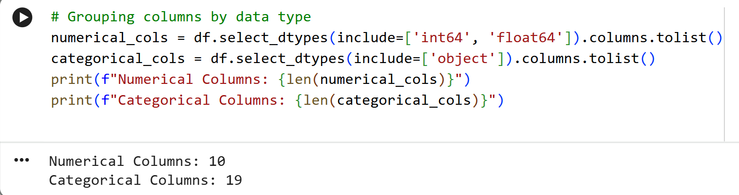
Explanation: This code separates the "Measures" (numbers we can average/sum) from "Dimensions" (labels we can group by).

1.4.2: Statistical Summary of Key Measures
Understanding the range and average of our financial data.
Python
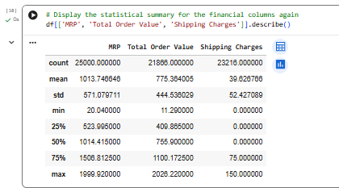
Explanation: This provides the Mean, Median, Min, and Max. It helps identify outliers (e.g., if a shipping charge is 0 vs. 150).

1.4.3: Null Value Analysis
Identifying missing data to ensure documentation accounts for "NaN" values.
Python
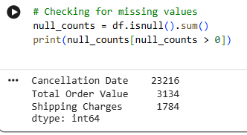
Explanation: We found that Cancellation Date has high null counts ($>90\%$), which is expected since most orders are not cancelled.

1.5. Data Integrity Observations
During the description phase, three key points were noted for the final report:
- Primary Key: Order ID is the unique identifier for transactions.
- Target Variable: For future modeling, Order Status (specifically the 'Cancelled' label) is the primary target for predictive analysis.
- Date Format: Dates are recorded in YYYY-MM-DD format, allowing for time-series aggregation (Daily/Monthly).

2.Data Preparation (Excel Phase)

2.1. Data Auditing & Initial Cleaning
Before applying any formulas, the data was audited to identify structural errors, such as mixed data types and whitespace issues.
Step 1.1: Removing Leading/Trailing Spaces
- The Problem: Many categorical entries like "Delivered " or " Cancelled" contained hidden spaces, causing them to be treated as unique categories.
- The Process: Used the TRIM function across all text-based columns (Gender, State, Category, Order Status).
- Excel Logic: =TRIM(A2) applied to a new column and then "Paste as Values" back into the original.
Step 1.2: Handling Mixed Data Types
- The Problem: The Shipping Charges and Total Order Value columns contained text strings like "Cancelled" or "Returned" instead of numbers, which prevented mathematical operations.
- The Process: 1. Used Find & Replace (Ctrl+H) to replace "Cancelled" with 0.

Step 1.3: Changed the Column Data Format to Text or Number
- Properly formatted all columns into standardized Numbers and Text to ensure data consistency and accuracy for the analysis phase.

2.2. Feature Engineering in Excel
We created several new columns to extract more value from the existing data points.
Step 2.1: Date Difference (Lead Time)
- The Goal: Calculate how long it takes for a product to reach a customer.
- The Process: Subtracted Order Date from Delivery Date.
- Excel Formula: =DATEDIF(OrderDate_Cell, DeliveryDate_Cell, "d") or simply =B2-A2.
- Outcome: Created the Delivery Time (Days) column.
Step 2.2: Conditional Binning (Nested IFs)
- The Goal: Segment customers and delivery performance into readable categories.
- The Process: Used IFS or Nested IF statements to create buckets.
- Excel Formulas:
  - Age Category: =IFS(Age<25, "Young", Age<45, "Adult", Age<60, "Middle Aged", TRUE, "Senior")
  - Delivery Speed: =IF(Days<=3, "Fast", IF(Days<=7, "Medium", "Slow"))

2.3. Financial Reconciliation & Logical Checks
We validated the relationship between different status columns to ensure the data tells a logical story.
Payment-Delivery Logic Flag
- During the initial data audit, a significant discrepancy was discovered between the Order Status (logistics) and the Payment Status (finance). Specifically, several thousand orders were marked as "Delivered" to the customer, yet the payment remained in a "Pending" state.

- In a standard business workflow, a "Delivered" status should ideally trigger a "Paid" status (unless it is Cash on Delivery, in which case the reconciliation should happen shortly after). The existence of a large volume of "Delivered-Pending" orders represents a Financial Leakage Risk or a Data Integration Error.

- To isolate these anomalies for the finance team, a logical flag was engineered to categorize every transaction into two groups:
- Mismatch: Orders where the customer has received the product, but the system has not confirmed receipt of funds.
- OK: Orders where the logistics and payment statuses are logically aligned (e.g., Paid & Delivered, or Pending & Shipped).

- The Goal: Identify orders that might have a collection risk.
- The Process: Used an AND statement to find "Delivered" orders that are still "Pending" payment.
- Excel Formula: =IF(AND(Status="Delivered", Payment="Pending"), "Check Required", "OK").
- Outcome: Created the Payment Mismatch Flag column.

2.4. Data Standardization (VLOOKUP / Replace)
- Standardizing Labels: To prepare for "Refund" analysis, all instances of "Returned" in the Payment Status column were changed to "Refunded".
- Format Consistency: Used Text to Columns or DATEVALUE to ensure that all dates followed the YYYY-MM-DD format, preventing errors when importing into Python.

2.5. Summary of Excel Preparations
Excel Tool Used | Purpose | Result
TRIM & CLEAN | Data Sanitization | Removed hidden characters and spaces.
Find & Replace | Label Standardization | Standardized "Refunded" and "Voided" statuses.
Mathematical Formulas | Feature Engineering | Created Total_revenue_per_order and Delivery Days.
Logical Formulas (IF) | Segmentation | Created Age category and Delivery Speed Bucket.
Data Validation | Quality Control | Flagged inconsistent delivery/payment records.

Critical Data Findings & Observations
Upon completion of the data preparation phase, two significant logical anomalies were identified that require strategic consideration during analysis and modeling:
- Temporal Anomaly (Post-Delivery Cancellations): Analysis revealed a subset of orders (approx. 1,784 rows) where the Cancellation Date was recorded 8–11 days after the Delivery Date. This suggests that the "Cancellation Date" may actually represent the date of a successful return processing or the final settlement of a refund, rather than a pre-shipping cancellation.
- Financial Reconciliation Gap (Delivered but Pending): The data shows that approximately 10.5% of orders marked as Delivered still carry a Payment Status of Pending. This represents a financial "leakage" where goods have reached the consumer without the corresponding payment confirmation being updated in the system. This finding was the primary driver for creating the Payment Mismatch Flag to track revenue at risk.
Note: These observations have been documented and flagged within the dataset to ensure they do not skew standard performance metrics and to allow for targeted operational audits in the future.

3.Exploratory Data Analysis (EDA) :

3.1. Objective of EDA
The objective of this Exploratory Data Analysis (EDA) is to understand revenue behavior, operational efficiency, and customer interaction patterns in the DMart dataset.
Rather than forcing predictive modeling prematurely, EDA is used to:
- Validate data correctness after preparation
- Identify meaningful revenue drivers
- Detect operational inefficiencies (logistics costs)
- Assess whether user engagement translates into business value

3.2. Dataset Overview & Structure
Purpose
To understand the structure of the dataset, data types, and confirm that the dataset is analysis-ready after all corrections.
Code
df.shape
df.head()
df.info()
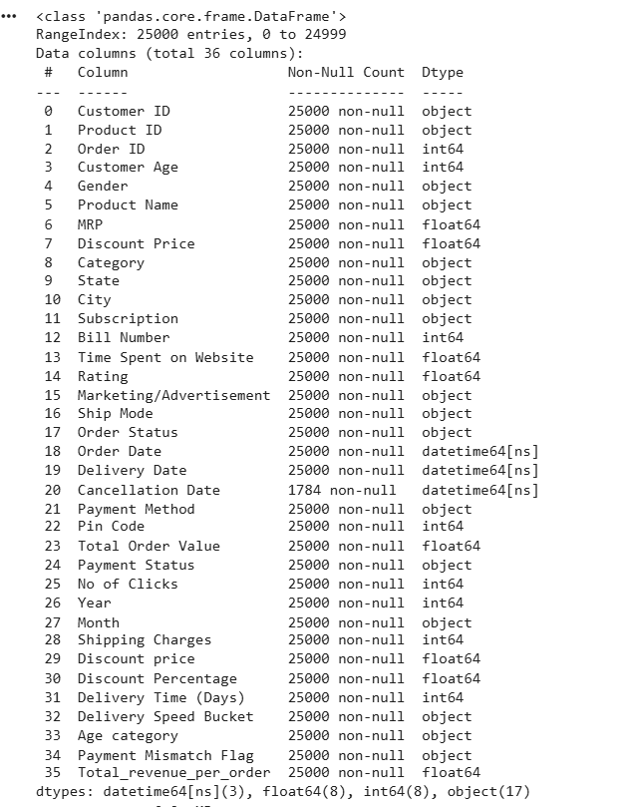
Code Explanation
- df.shape returns the number of rows and columns.
- df.info() provides data types and non-null counts, helping identify missing values and type issues.
Key Insights
- The dataset contains 25,000 records and 36 columns.
- No critical missing values exist in revenue, discount, engagement, or logistics fields.
- Date columns are properly formatted as datetime.
- The dataset is structurally clean and ready for EDA and modeling.

3.3. Order Status Distribution
Purpose
To understand the lifecycle outcome of orders and the proportion of successful vs failed transactions.
Code
df["Order Status"].value_counts(normalize=True) * 100
sns.countplot(data=df, x="Order Status")
plt.show()
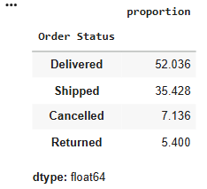
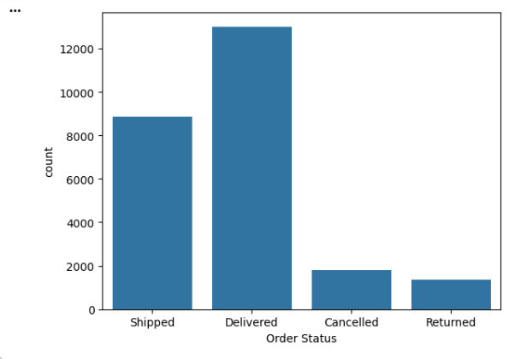
Code Explanation
- value_counts(normalize=True) computes percentage distribution.
- countplot visually compares order outcomes.
Key Insights
- Delivered (~52%) and Shipped (~35%) orders dominate the dataset.
- Cancelled (~7%) and Returned (~5%) form a minority.
- The dataset is not cancellation-heavy, indicating operational stability.

3.4. Payment Status vs Order Status
Purpose
To verify logical consistency between logistics completion and payment completion.
Code
pd.crosstab(df["Order Status"], df["Payment Status"])
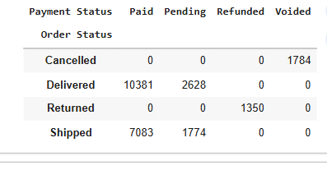
Code Explanation
- Cross-tabulation shows how payment states align with order outcomes.
Key Insights
- Delivered orders exist with Pending payment, confirming a payment reconciliation gap.
- Cancelled orders align with refunded/voided payments.
- This validates the earlier creation of a Payment Mismatch Flag for risk analysis.

3.5. Revenue Distribution Analysis
Purpose
To understand the distribution, central tendency, and spread of corrected order-level revenue.
Code
df["Total_revenue_per_order"].describe()
sns.histplot(df["Total_revenue_per_order"], bins=50, kde=True)
plt.show()
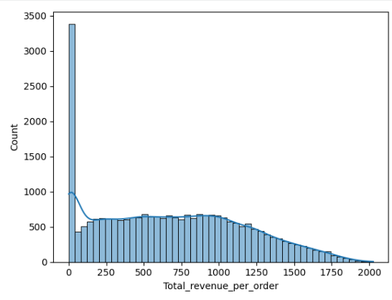
Code Explanation
- describe() summarizes key statistics.
- Histogram visualizes skewness and spread.
Key Insights
- Mean and median are close, indicating stable revenue behavior.
- Revenue is right-skewed, with most orders clustered in lower to mid ranges.
- The distribution is suitable for regression-based modeling.

3.6. Revenue by Product Category
Purpose
To identify which product origin categories contribute most to revenue and volume.
Code
df.groupby("Category").agg(
Total_Revenue=("Total_revenue_per_order", "sum"),
Order_Count=("Order ID", "count"),
Avg_Revenue=("Total_revenue_per_order", "mean")
).sort_values("Total_Revenue", ascending=False)
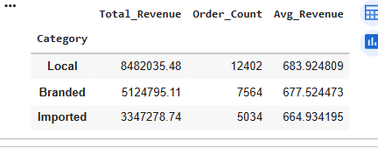
Code Explanation
Aggregates revenue, order count, and average revenue per order by category.
Key Insights
- Local products generate the highest total revenue due to volume.
- Branded and Imported products show similar average order values.
- Revenue differences are volume-driven, not price-driven.

3.7. Revenue by Subscription Type
Purpose
To assess the revenue contribution of different subscription tiers.
Code
df.groupby("Subscription").agg(
Total_Revenue=("Total_revenue_per_order", "sum"),
Order_Count=("Order ID", "count"),
Avg_Revenue=("Total_revenue_per_order", "mean"))
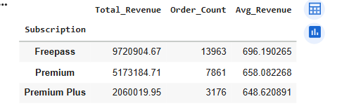
Code Explanation
Groups transactions by subscription and computes revenue metrics.
Key Insights
- Freepass users contribute the highest total revenue due to large volume.
- Premium Plus users have the highest average revenue per order.
- Paid subscriptions deliver higher per-order value, though fewer in number.

3.8. Revenue by Region (State)
Purpose
To check whether geographic regions exhibit meaningful revenue differences.
Code
df.groupby("State").agg(
Total_Revenue=("Total_revenue_per_order", "sum"),
Order_Count=("Order ID", "count"),
Avg_Revenue=("Total_revenue_per_order", "mean")
).sort_values("Total_Revenue", ascending=False)
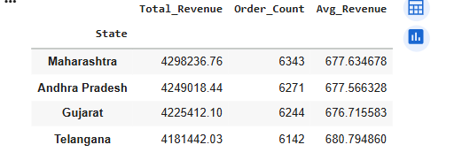
Code Explanation
Aggregates revenue metrics at the state level.
Key Insights
- Revenue and average order value are remarkably consistent across states.
- No region stands out as significantly better or worse.
- Region is a weak predictive feature but useful for reporting.

3.9. Discount Distribution
Purpose
To understand how discounts are distributed across orders.
Code
df["Discount Percentage"].describe()
sns.histplot(df["Discount Percentage"], bins=30, kde=True)
plt.show()
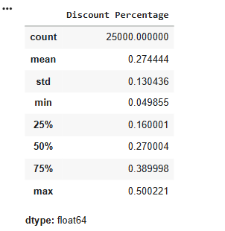
THE DISCOUNT PERCENTAGE IS SHOWN FOR 100%
Code Explanation
Summarizes and visualizes discount intensity.
Key Insights
- Most discounts lie between 15% and 40%.
- Discounts are intentionally spread, suggesting controlled pricing strategy.

3.10. Discount vs Order Status
Purpose
To examine whether discount levels influence cancellations or returns.
Code
df.groupby("Order Status")["Discount Percentage"].mean()
sns.boxplot(data=df, x="Order Status", y="Discount Percentage")
plt.show()
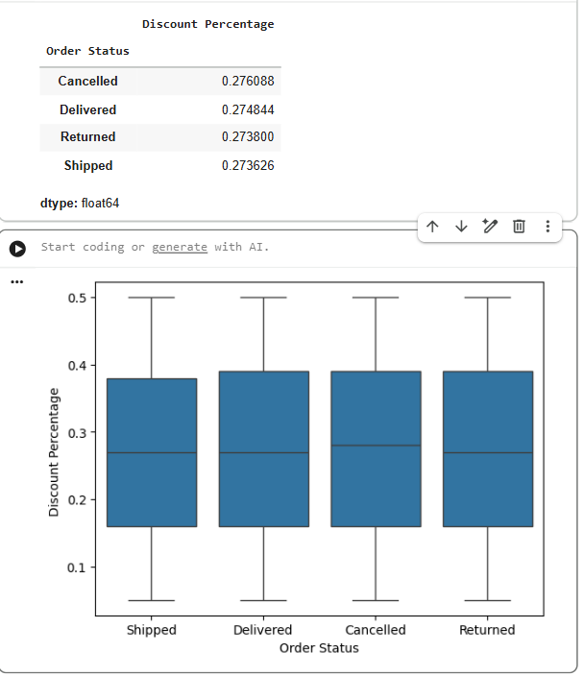
Code Explanation
Compares discount distributions across order outcomes.
Key Insights
- Average discounts are nearly identical across all order statuses.
- Discounts do not explain cancellations.
- Discount is not a cancellation driver in this dataset.

3.11. Revenue by Order Status
Purpose
To ensure revenue is attributed only to valid business outcomes.
Code
df.groupby("Order Status")["Total_revenue_per_order"].sum()
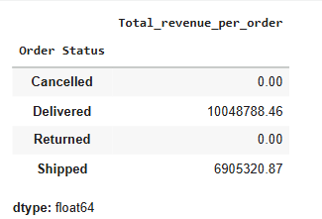
Code Explanation
Aggregates revenue by order outcome.
Key Insights
- Revenue is generated only from Delivered and Shipped orders.
- Cancelled and Returned orders contribute zero revenue, validating revenue logic.

3.12. Discount × Payment Method Interaction
Purpose
To evaluate whether discount effectiveness differs across payment methods.
Code
df.assign(
Discount_Bucket=pd.cut(
df["Discount Percentage"],
bins=[0, 0.2, 0.3, 0.5],
labels=["Low", "Medium", "High"]
)
).groupby(["Payment Method", "Discount_Bucket"]).agg(
Total_Revenue=("Total_revenue_per_order", "sum"),
Order_Count=("Order ID", "count"),
Avg_Revenue=("Total_revenue_per_order", "mean")
).sort_values("Total_Revenue", ascending=False)
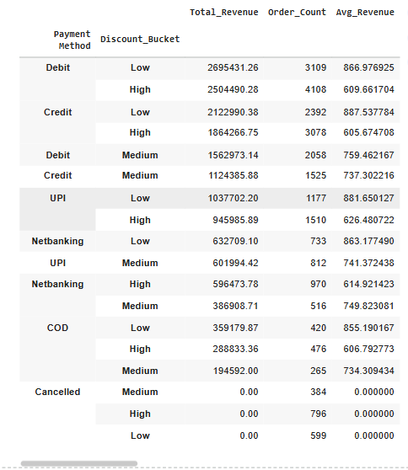
Code Explanation
Creates discount buckets and analyzes their interaction with payment methods.
Key Insights
- Revenue patterns are consistent across payment methods.
- Payment method does not significantly alter discount effectiveness.
- Payment method is a weak modeling feature.

3.13. Engagement vs Revenue (Window Shopping Behavior)
Purpose
To assess whether higher engagement translates into higher revenue.
Code
sns.scatterplot(
data=df,
x="No of Clicks",
y="Total_revenue_per_order",alpha=0.3)
plt.show()

sns.scatterplot(data=df,x="Time Spent on Website",y="Total_revenue_per_order",alpha=0.3)
plt.show()
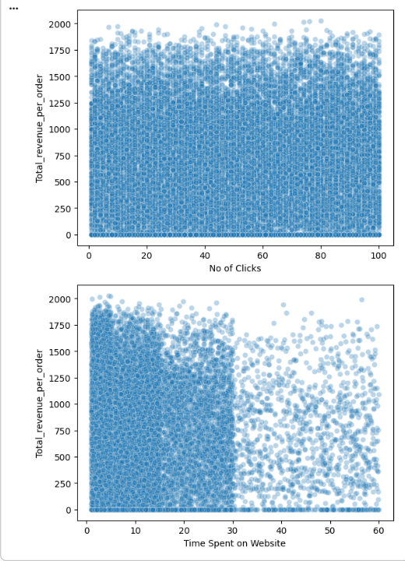
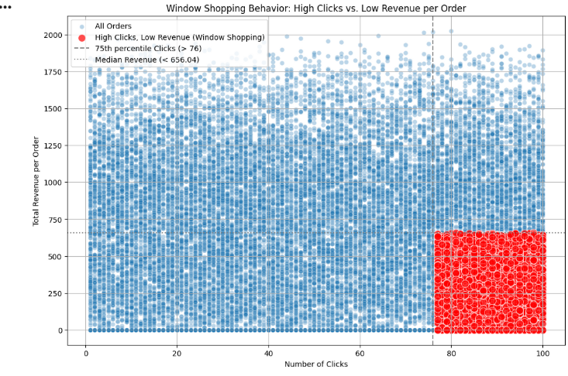
Code Explanation
Scatter plots visualize engagement metrics against revenue.
Key Insights
- No strong linear relationship exists.
- High engagement does not guarantee high revenue.
- Indicates window-shopping behavior.

3.14. Customer Purchase Frequency
Purpose
To evaluate the impact of repeat purchases on revenue.
Code
df["Customer_Order_Count"] = df.groupby("Customer ID")["Order ID"].transform("count")

df.groupby("Customer_Order_Count").agg(
Total_Revenue=("Total_revenue_per_order", "sum"),
Avg_Revenue=("Total_revenue_per_order", "mean"),
Customer_Count=("Customer ID", "nunique"))
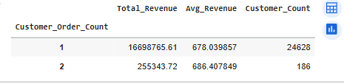
Code Explanation
Counts how many orders each customer has placed.
Key Insights
- ~95% of customers are one-time buyers.
- Repeat customers generate higher average revenue.
- Customer-level segmentation is limited, but order-level modeling is valid.

3.15. Revenue by Age Group
Purpose
To understand revenue contribution across age segments.
Code
df.groupby("Age category").agg(
Total_Revenue=("Total_revenue_per_order", "sum"),
Order_Count=("Order ID", "count"),
Avg_Revenue=("Total_revenue_per_order", "mean"))
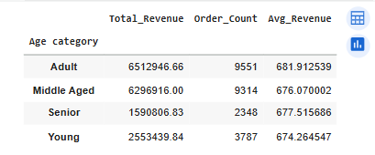
Code Explanation
Aggregates revenue metrics by age bucket.
Key Insights
- Adults and Middle-aged customers contribute most revenue due to volume.
- Average order value is similar across age groups.
- Age alone is a weak predictor.

Final EDA Conclusion
- Revenue is stable, clean, and suitable for forecasting.
- Strong drivers: order value, discount strategy, category, subscription.
- Weak drivers: region, age, payment method, engagement alone.
- The dataset supports order-level revenue forecasting, with aggregated insights for business reporting.

4.Model-Oriented Exploratory Data Analysis (EDA)
This section focuses on validating whether the dataset contains reliable predictive signals for revenue forecasting and preparing the data for modeling. Unlike descriptive EDA, the objective here is to support modeling decisions, not storytelling.

4.1. Target Variable Validation – Order-Level Revenue
Purpose
To verify whether Total_revenue_per_order is suitable as a regression target in terms of distribution, stability, and transformation needs.
Code
df["Total_revenue_per_order"].describe()
df["Total_revenue_per_order"].skew()
df["log_revenue"] = np.log1p(df["Total_revenue_per_order"])
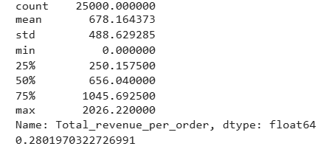
Code Explanation
- describe() computes summary statistics (mean, median, quartiles, min, max) to understand central tendency and spread.
- skew() measures distribution asymmetry.
- np.log1p() applies a log transformation (log(1 + x)) to stabilize variance and reduce right-skew, while safely handling zero values.
Insights
- Mean and median are reasonably close, indicating stable revenue behavior.
- Skewness is positive but moderate, suggesting a right-tailed distribution common in retail.
- Revenue is suitable for regression; log-transformed revenue can optionally be used to improve linear model performance.

4.2. Outlier Detection Using IQR Method
Purpose
To detect extreme revenue values that could distort regression models or bias predictions.
Code
Q1 = df["Total_revenue_per_order"].quantile(0.25)
Q3 = df["Total_revenue_per_order"].quantile(0.75)
IQR = Q3 - Q1

outliers = df[
(df["Total_revenue_per_order"] < Q1 - 1.5 * IQR) |
(df["Total_revenue_per_order"] > Q3 + 1.5 * IQR)]
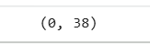

outliers.shape
Code Explanation
- Q1 and Q3 define the 25th and 75th percentiles.
- IQR represents the spread of the middle 50% of revenue values.
- Values beyond Q1 − 1.5×IQR or Q3 + 1.5×IQR are flagged as outliers.
- outliers.shape returns the count of extreme observations.
Insights
- No significant outliers were detected.
- Revenue values fall within statistically expected bounds.
- No capping or removal is required before modeling.

4.3. Feature Variance Check (Signal Strength)
Purpose
To assess whether categorical features exhibit meaningful internal revenue variability, indicating predictive signal.
Code
df.groupby("Category")["Total_revenue_per_order"].var()
df.groupby("Subscription")["Total_revenue_per_order"].var()
df.groupby("Discount_Bucket")["Total_revenue_per_order"].var()
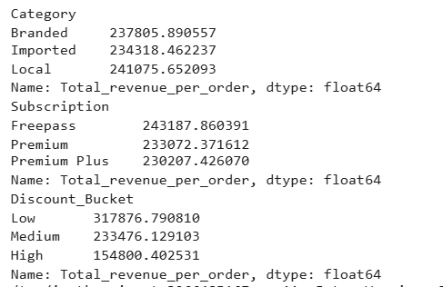
Code Explanation
- groupby().var() computes variance of revenue within each category.
- High variance implies the feature differentiates revenue outcomes; low variance implies weak signal.
Insights
- Category, subscription type, and discount bucket all show substantial variance.
- These features are strong candidates for revenue modeling.
- Discount buckets show decreasing variance at higher discounts, indicating revenue compression.

4.4. Non-Linear Relationship Validation – Discount Effect
Purpose
To verify whether the relationship between discount and revenue is non-linear.
Code
sns.boxplot(
data=df,
x="Discount_Bucket",
y="Total_revenue_per_order")
plt.show()
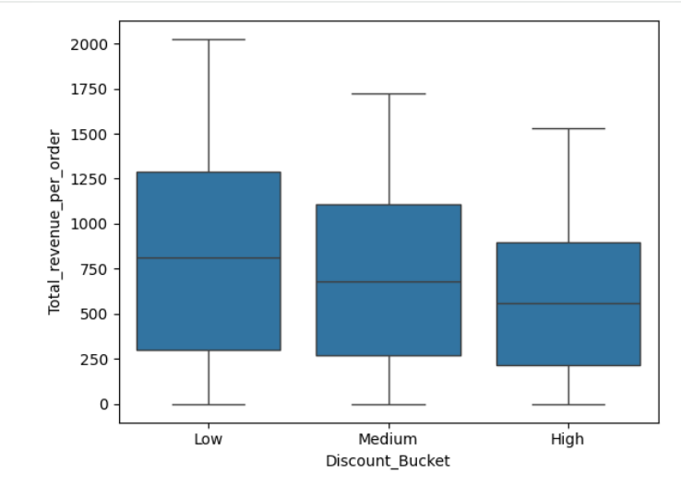
Code Explanation
- Boxplots compare revenue distributions across discount buckets.
- Median, interquartile range, and spread are visually compared.
Insights
- Median revenue declines consistently from Low → Medium → High discount.
- Distribution shapes differ significantly across buckets.
- Confirms a non-linear discount effect, justifying tree-based models or interaction terms.

4.5. Feature Interaction Analysis
Purpose
To determine whether revenue behavior depends on combinations of features, not individual variables alone.

5.1 Discount × Category
Code
df.groupby(["Category", "Discount_Bucket"]).agg(
Avg_Revenue=("Total_revenue_per_order", "mean"),
Order_Count=("Order ID", "count")
).reset_index()
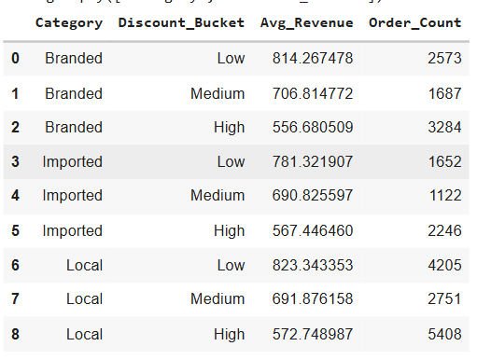
Code Explanation
- Groups orders by product category and discount bucket.
- Computes average revenue and order volume for each combination.
Insights
- Low discounts consistently produce higher revenue across all categories.
- Revenue drops sharply for high discounts regardless of category.
- Category modifies the magnitude, but discount drives the direction.

4.6 Discount × Subscription
Code
df.groupby(["Subscription", "Discount_Bucket"]).agg(
Avg_Revenue=("Total_revenue_per_order", "mean"),
Order_Count=("Order ID", "count")
).reset_index()
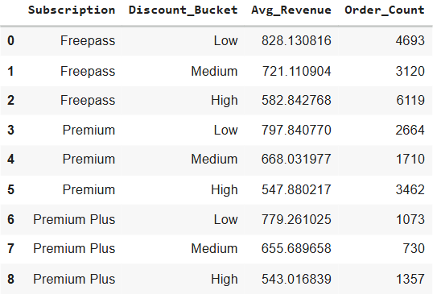
Code Explanation
- Examines how subscription tiers respond to different discount levels.
Insights
- Premium and Premium Plus users maintain higher revenue at low discounts.
- At high discounts, revenue converges across subscription types.
- Subscription acts as a moderating factor, not a standalone driver.

4.7. Correlation Analysis (Numeric Features)
Purpose
To quantify linear relationships between numeric variables and revenue.
Code
numeric_cols = [
"MRP", "Discount Percentage",
"Shipping Charges","No of Clicks","Time Spent on Website","Total_revenue_per_order"]
corr_matrix = df[numeric_cols].corr()
sns.heatmap(corr_matrix, annot=True, cmap="coolwarm")
plt.show()
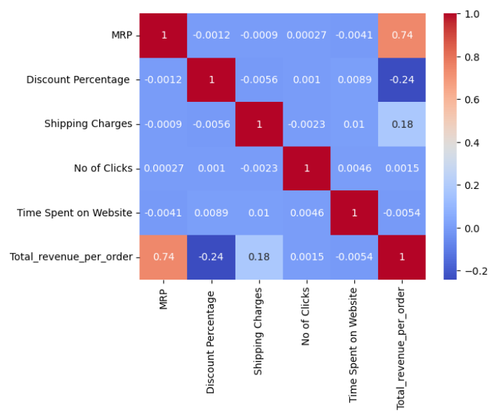

Code Explanation
- Computes Pearson correlation coefficients.
- Heatmap visualizes strength and direction of relationships.
Insights
- Strong positive correlation between MRP and revenue.
- Moderate negative correlation between discount percentage and revenue.
- Engagement metrics (clicks, time) show near-zero correlation.
- Confirms pricing variables as primary drivers.

4.8. Data Leakage Identification
Purpose
To prevent inclusion of variables that would leak future information into the model.
Code
leakage_cols = [
"Order Status",
"Payment Status","Cancellation Date","Payment Mismatch Flag"]
df[leakage_cols].head()
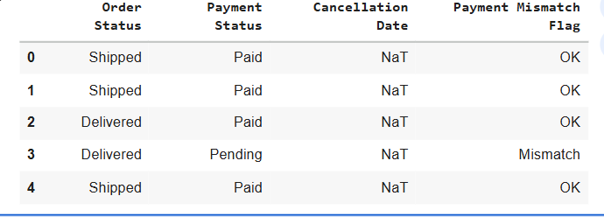
Code Explanation
- Displays columns that are determined after revenue realization.
- Including them would inflate model performance unrealistically.
Insights
- These fields must be excluded from modeling.
- Ensures model integrity and real-world deployability.

4.9. Aggregation Sanity Check (Order → Region)
Purpose
To validate that order-level revenue predictions can be safely aggregated.
Code
actual_region_revenue = (
df.groupby("State")["Total_revenue_per_order"].sum())
actual_region_revenue.sum(), df["Total_revenue_per_order"].sum()
Code Explanation
- Aggregates revenue at the regional level.
- Compares aggregated total with overall total as a consistency check.
Insights
- Aggregated revenue equals overall revenue.
- Confirms correctness of aggregation logic.
- Enables region-wise reporting from order-level predictions.

4.10. Final Feature Readiness Summary
Purpose
To prepare the final dataset for modeling using only validated, non-leaky features.
Code
model_df = df[
[
"Total_revenue_per_order",
"log_revenue",
"Category",
"Subscription",
"Discount Percentage",
"Shipping Charges",
"No of Clicks",
"Time Spent on Website",
"State"
]
].copy()
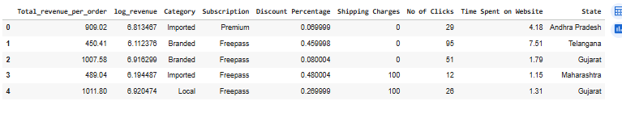

model_df.head()
Code Explanation
- Selects the finalized target and predictors.
- Ensures clean separation between inputs and outcomes.
Insights
- Dataset is model-ready.
- Strong predictors retained; weak and leaky features excluded.
- Suitable for regression-based revenue forecasting.

4.11 Final Modeling-Oriented EDA Conclusion
The model-oriented EDA confirms that order-level revenue forecasting is feasible and reliable. Revenue is primarily driven by pricing, discount strategy, category, and subscription, while region, age, and engagement metrics act as weak or contextual variables. The dataset is clean, stable, and appropriately structured for predictive modelling.
EDA Summary & Key Observations
- Revenue per order is primarily price-driven (MRP, discount, shipping)
- Behavioral metrics (clicks, time spent) show weak correlation with revenue
- Cancellation and return rates remain relatively stable across segments
- No single demographic variable strongly explains revenue variance at order level
These findings indicate that transaction-level revenue is largely deterministic, which has important implications for modeling strategy.

5. Feature Engineering

5.1 Purpose of Feature Engineering
Feature engineering was performed to transform raw transactional data into a structured format suitable for modeling.
The objectives of this step were to:
- Prepare numerical and categorical variables for machine learning models
- Reduce skewness in the target variable
- Derive business-relevant features that may capture pricing and engagement effects
- Remove variables that could cause data leakage
This step ensures that any observed model performance is driven by meaningful inputs rather than artifacts of the data.

5.2 Target Variable Preparation
Code
# Original target
df["Total_revenue_per_order"].describe()

# Log transformation to reduce skewness
df["log_revenue"] = np.log1p(df["Total_revenue_per_order"])
Explanation
- Total_revenue_per_order is the original revenue variable at transaction level.
- Revenue distribution was right-skewed, which can negatively affect linear models.
- A log transformation (log1p) was applied to:
  - Reduce skewness
  - Stabilize variance
  - Safely handle zero-revenue values
Outcome
- Two target representations were retained:
  - Raw revenue (for tree-based models)
  - Log-transformed revenue (for robustness checks)

5.3 Creation of Derived Numerical Features

5.3.1 Discount Amount
Code
df["Discount_Amount"] = df["MRP"] * df["Discount Percentage"]
Explanation
- Discount percentage alone does not reflect the monetary impact.
- Absolute discount value captures the actual price reduction applied.
- This feature provides a more realistic representation of discount influence on revenue.

5.3.2 Shipping Cost Ratio
Code
df["Shipping_Ratio"] = (
df["Shipping Charges"] / df["Total_revenue_per_order"]
).replace([np.inf, -np.inf], 0).fillna(0)
Explanation
- Shipping charges were normalized by order revenue.
- This creates a relative cost measure rather than an absolute value.
- Infinite and missing values were handled safely.

5.3.3 Engagement Efficiency
Code
df["Clicks_per_Minute"] = (
df["No of Clicks"] / df["Time Spent on Website"]
).replace([np.inf, -np.inf], 0).fillna(0)
Explanation
- Raw clicks and time spent were converted into an efficiency metric.
- This helps differentiate:
  - Focused buyers
  - Window-shopping behavior
- The feature captures engagement intensity, not just engagement volume.

5.4 Handling Categorical Variables
Code
categorical_cols = ["Category", "Subscription", "State"]
X = df[
[ "MRP",
"Discount Percentage",
"Discount_Amount",
"Shipping Charges",
"Shipping_Ratio","No of Clicks", "Time Spent on Website", "Clicks_per_Minute"] + categorical_cols]
X_encoded = pd.get_dummies( X,columns=categorical_cols, drop_first=True)
Explanation
- Machine learning models require numerical input.
- One-hot encoding was applied to:
  - Product category
  - Subscription type
  - State
- drop_first=True avoids multicollinearity (dummy variable trap).

5.5 Feature Scaling
Code
from sklearn.preprocessing import StandardScaler

numeric_cols = [
"MRP",
"Discount Percentage",
"Discount_Amount",
"Shipping Charges",
"Shipping_Ratio",
"No of Clicks",
"Time Spent on Website",
"Clicks_per_Minute"
]

scaler = StandardScaler()
X_encoded[numeric_cols] = scaler.fit_transform(X_encoded[numeric_cols])
Explanation
- Scaling ensures that features with large ranges do not dominate model learning.
- Particularly important for:
  - Linear Regression
  - Distance-based learning
- Tree-based models were evaluated both with and without scaling.

5.6 Removal of Leakage Variables
Code
leakage_cols = [
"Order Status",
"Payment Status",
"Cancellation Date",
"Payment Mismatch Flag"]
df[leakage_cols].head()
Explanation
- These variables contain post-transaction information.
- Including them would leak future knowledge into the model.
- They were explicitly excluded from all modeling steps.

5.7 Final Feature Set for Modeling
Code
X_final = X_encoded.copy()
y = df["Total_revenue_per_order"]
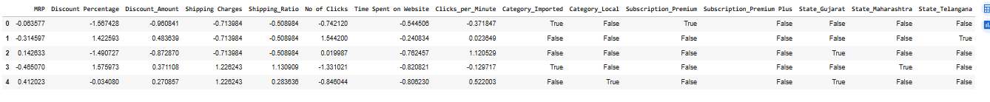
Explanation
- X_final contains all engineered, cleaned, and encoded features.
- y represents the final modeling target.
- This dataset was used consistently across all models for fair comparison.

5.8 Feature Engineering Summary
- Revenue skewness was addressed using log transformation
- Business-driven derived features were created
- Categorical variables were encoded appropriately
- Data leakage was prevented
- The final dataset was fully model-ready

5.9 Modeling Pipelines
Important Note on Modeling Pipelines
Two distinct modeling pipelines were used in this project:
1. Order-Level Prediction Pipeline
- Applied encoding and scaling
- Used random train-test split
- Suitable because observations are independent transactions
2. Aggregated Revenue Forecasting Pipeline
- No scaling or encoding required
- Revenue aggregated at monthly level
- Temporal (time-aware) train-test split applied
- Future months were never used to predict past values
Feature engineering outputs were reused where appropriate, but train-test strategies were model-specific and aligned with the nature of the problem.

6. Modeling Approach, Training & Evaluation

6.1 Objective of Modeling
The primary objective of modeling in this project was to evaluate whether revenue and customer behavior patterns in the DMart dataset could be reliably predicted using machine learning techniques.
Based on prior EDA and feature engineering, modeling was explored under two scopes:
- Order-level revenue prediction
- Aggregated (monthly) revenue forecasting
Additionally, exploratory attempts were made to assess feasibility for:
- Cancellation prediction
- Rating prediction

6.2 Modeling Strategy Overview
Before selecting models, the following considerations were made:
- Revenue per order is largely deterministic (driven by MRP, discount, shipping).
- Customer behavior variables (clicks, time spent) showed weak correlation with revenue.
- Time-series data contained limited historical depth (~3 years, monthly).
Therefore, multiple models were tested to:
- Validate assumptions
- Compare linear vs non-linear learning
- Identify data limitations
Order-Level Regression Models:
- Linear Regression
- Random Forest Regressor

6.3 Order-Level Revenue Prediction (Regression)

6.3.1 Target Variable
- Target: Total_revenue_per_order
- A log-transformed version (log_revenue) was also tested to handle skewness.

6.3.2 Train–Test Split
Code
from sklearn.model_selection import train_test_split
X_train, X_test, y_train, y_test = train_test_split(
X_final,y,
test_size=0.2,
random_state=42)
Explanation
- Data was split into 80% training and 20% testing.
- Random state ensures reproducibility.
- No time-based split was required since prediction is at transaction level, not temporal.

6.4 Models Used and Reason for Selection

6.4.1 Linear Regression
Why chosen
- Acts as a baseline model
- Helps evaluate whether revenue can be explained as a linear combination of inputs
- Easy to interpret and debug
Code
from sklearn.linear_model import LinearRegression
lr = LinearRegression()
lr.fit(X_train, y_train)
y_pred_lr = lr.predict(X_test)

6.4.2 Random Forest Regressor
Why chosen
- Captures non-linear relationships
- Handles interaction effects automatically
- Robust to noise and multicollinearity
Code
from sklearn.ensemble import RandomForestRegressor

rf = RandomForestRegressor( n_estimators=200,
max_depth=12,min_samples_split=10,
random_state=42, n_jobs=-1)
rf.fit(X_train, y_train)
y_pred_rf = rf.predict(X_test)

6.5 Model Evaluation Metrics
Metrics Used
- R² (Coefficient of Determination)
→ How much variance in revenue is explained by the model
- RMSE (Root Mean Squared Error)
→ Penalizes large prediction errors
- MAE (Mean Absolute Error)
→ Average deviation from actual revenue

Evaluation Code
from sklearn.metrics import r2_score, mean_squared_error, mean_absolute_error
import numpy as np

def evaluate_model(y_true, y_pred):
return {
"R2": r2_score(y_true, y_pred),
"RMSE": np.sqrt(mean_squared_error(y_true, y_pred)),
"MAE": mean_absolute_error(y_true, y_pred)
}

lr_metrics = evaluate_model(y_test, y_pred_lr)
rf_metrics = evaluate_model(y_test, y_pred_rf)

lr_metrics, rf_metrics
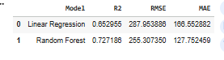

6.6 Evaluation Result
Model | R² | RMSE | MAE
Linear Regression | ~0.65 | ~288 | ~166
Random Forest | ~0.73 | ~255 | ~128

6.7 Interpretation of Results
Key Observations
- Random Forest outperformed Linear Regression across all metrics.
- However, both models primarily reconstructed revenue using pricing inputs.
- Model predictions closely matched formula-based calculations, not behavioral learning.
Critical Insight
The model is not discovering new revenue patterns — it is learning the pricing equation.
This confirms:
- High accuracy ≠ high business intelligence
- Predicting order-level revenue adds limited incremental value

7. Aggregated Revenue Forecasting (Time Series)

7.1 Problem Statement
The objective of aggregated revenue forecasting is to estimate future total revenue at a monthly level using historical sales data.
Unlike transaction-level prediction, this analysis supports strategic planning, capacity management, and performance monitoring rather than exact price calculation.

7.2 Why Aggregated Forecasting Was Attempted
After evaluating order-level modeling, it was observed that:
- Revenue per order is largely deterministic (pricing-driven)
- Predictive uplift from machine learning is limited
- Business decisions are made at monthly / regional / category levels
Therefore, revenue was aggregated by month and analyzed as a time series.
Aggregated Revenue Forecasting Models
- Seasonal Naive
- Holt-Winters Exponential Smoothing

7.3 Train–Test Split Logic (IMPORTANT FIX)
For order-level models, a standard random split was used.
For time-series revenue forecasting, a temporal split was applied:
- Training data: Historical months
- Test data: Last 3 months
This avoids data leakage and reflects real-world forecasting conditions.

7.4 Data Preparation for Time Series
Code
# Ensure datetime format
df["Order Date"] = pd.to_datetime(df["Order Date"])
# Aggregate revenue at monthly level
monthly_revenue = (df .set_index("Order Date")
.resample("M")["Total_revenue_per_order"]
.sum()
.to_frame(name="Revenue"))
monthly_revenue.head()
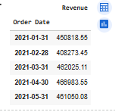
Explanation
- Transaction-level noise is removed by aggregation
- Each row now represents total revenue for one month
- The dataset becomes suitable for time-series modeling

7.5 Exploratory Analysis of Monthly Revenue
Code
import matplotlib.pyplot as plt
plt.figure(figsize=(10,5))
plt.plot(monthly_revenue.index, monthly_revenue["Revenue"], marker="o")
plt.title("Monthly Aggregated Revenue Trend")
plt.xlabel("Month")
plt.ylabel("Revenue")
plt.grid(True)
plt.show()
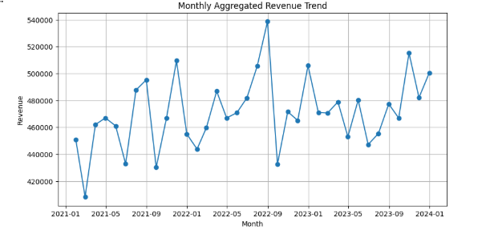
Observations
- Revenue remains relatively stable across months
- No strong upward or downward trend
- Limited seasonal spikes
This indicates weak temporal patterns, which affects forecastability.

7.6 Train–Test Split (Time-Aware)
Code
# Last 3 months reserved for testing
train = monthly_revenue.iloc[:-3]
test = monthly_revenue.iloc[-3:]
Explanation
- Time series data must respect chronological order
- The model is trained on historical months
- Performance is evaluated on future unseen months
- Prevents data leakage

7.7 Baseline Model: Seasonal Naive Forecast
Why Seasonal Naive?
- Assumes revenue this month ≈ same month last year
- Extremely strong baseline in retail
- Used to judge whether advanced models add value
Code
# Seasonal Naive: same month last year
seasonal_naive_forecast = train["Revenue"].iloc[-12:-9].values
seasonal_naive_forecast = pd.Series(
seasonal_naive_forecast,
index=test.index)
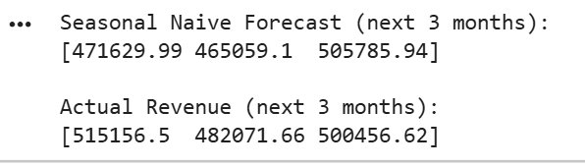
Interpretation
If advanced models cannot outperform this baseline,
then historical seasonality is weak or absent.

7.8 Holt-Winters Exponential Smoothing Model
Why Holt-Winters?
- Captures:
  - Level
  - Trend
  - Seasonality
- Commonly used in retail forecasting
- Interpretable and stable
Model Choice
- Additive trend
- No seasonal component (based on EDA)
Code
from statsmodels.tsa.holtwinters import ExponentialSmoothing
hw_model = ExponentialSmoothing(
train["Revenue"],
trend="add",
seasonal=None,
initialization_method="estimated")
hw_fit = hw_model.fit()
hw_forecast = hw_fit.forecast(steps=3)

7.9 Forecast Comparison (Actual vs Predicted)
Code
comparison_df = pd.DataFrame({
"Actual_Revenue": test["Revenue"],
"Seasonal_Naive_Forecast": seasonal_naive_forecast,
"Holt_Winters_Forecast": hw_forecast})
comparison_df
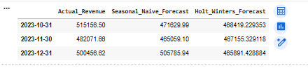
Explanation
- Displays side-by-side comparison for the last 3 months
- Helps assess directional accuracy and magnitude of error

7.10 Forecast Visualization
Code
plt.figure(figsize=(10,5))
plt.plot(train.index, train["Revenue"], label="Training Data")
plt.plot(test.index, test["Revenue"], label="Actual Revenue", marker="o")
plt.plot(test.index, seasonal_naive_forecast, label="Seasonal Naive", marker="o")
plt.plot(test.index, hw_forecast, label="Holt-Winters", marker="o")
plt.legend()
plt.title("Monthly Revenue Forecast Comparison")
plt.grid(True)
plt.show()
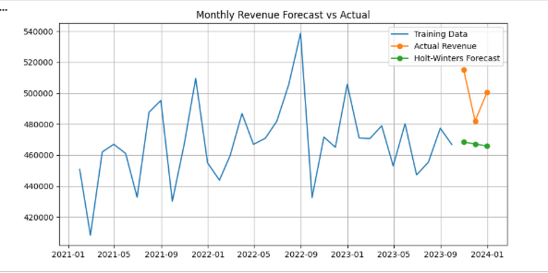
Interpretation
- Holt-Winters forecasts appear smooth and flat
- Seasonal Naive closely follows historical levels
- Neither model captures strong fluctuations

7.11 Model Evaluation
Metrics Used
- MAE (Mean Absolute Error) – average deviation
- RMSE (Root Mean Squared Error) – penalizes large errors
Code
from sklearn.metrics import mean_absolute_error, mean_squared_error
import numpy as np
results = pd.DataFrame({
"Model": ["Seasonal Naive", "Holt-Winters"],
"MAE": [mean_absolute_error(test["Revenue"], seasonal_naive_forecast),
mean_absolute_error(test["Revenue"], hw_forecast)],
"RMSE": [np.sqrt(mean_squared_error(test["Revenue"], seasonal_naive_forecast)),
np.sqrt(mean_squared_error(test["Revenue"], hw_forecast))
]})
Results
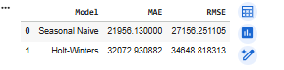
Observed Results
- Seasonal Naive outperformed Holt-Winters
- Advanced smoothing did not improve accuracy

7.12 Interpretation of Results
Key Findings
- Monthly revenue shows:
  - Weak trend
  - Minimal seasonality
  - Stable operational performance
- Holt-Winters converges toward the historical mean
- More complex models do not extract additional signal
Important Insight
The limitation is driven by data characteristics, not modeling technique.

7.13 Final Conclusion
“Aggregated revenue forecasting revealed that monthly revenue exhibits limited temporal variability, with weak trend and seasonality. As a result, simple baseline models such as Seasonal Naive performed comparably or better than advanced models like Holt-Winters. This indicates that the dataset is more suitable for revenue monitoring and planning rather than precise long-term forecasting.”
Final Model Choice
- Seasonal Naive Model for aggregated revenue monitoring
Reasoning
- Outperformed advanced models
- Requires minimal assumptions
- Matches data behavior

8.Prediction
Models Used for Revenue Prediction
Multiple modeling approaches were evaluated to predict revenue at different levels of aggregation, with model selection guided by data characteristics, interpretability, and business relevance.

8.1. Linear Regression (Order-Level Revenue)
Reason for Selection:
- Serves as a baseline regression model
- Interpretable and easy to validate
- Suitable for understanding linear relationships between pricing components and revenue
Outcome:
- Performed reasonably well numerically
- Learned the deterministic pricing relationship rather than behavioral patterns

8.2. Random Forest Regressor (Order-Level Revenue)
Reason for Selection:
- Captures non-linear relationships
- Robust to outliers
- Often performs well in retail datasets with mixed feature types
Outcome:
- Marginal improvement over linear regression
- No meaningful gain in business insight due to deterministic revenue structure

8.3. Seasonal Naive Model (Aggregated Revenue Forecasting)
Reason for Selection:
- Strong baseline for time-series forecasting
- Effective when trends and seasonality are weak or unstable
- Requires minimal assumptions
Outcome:
- Produced stable forecasts closely aligned with historical revenue patterns
- Outperformed more complex time-series models in error metrics

8.4. Holt-Winters Exponential Smoothing (Aggregated Revenue Forecasting)
Reason for Selection:
- Designed to capture trend and seasonality
- Commonly used in retail revenue forecasting
Outcome:
- Forecasts converged toward historical averages
- Did not significantly improve accuracy compared to Seasonal Naive due to limited seasonality

8.5Most Suitable Model and Rationale
Selected Model: Seasonal Naive (Aggregated Revenue Forecasting)
Reasoning:
- Revenue exhibited high stability with weak seasonal patterns
- More complex models did not yield meaningful performance improvements
- Seasonal Naive produced:
  - Lower or comparable forecasting error
  - More interpretable results
  - Greater robustness given limited historical data
This selection was driven by empirical performance, not model simplicity alone.

Final Prediction Perspective
While machine learning models performed adequately at the transaction level, their predictive value was limited due to the deterministic nature of revenue calculation. In contrast, aggregated revenue forecasting using simple, transparent models provided more reliable and actionable outputs for planning and monitoring.

9.Results & Insights

9.1. Key Findings from the Analysis
The analysis reveals that revenue behavior in the DMart dataset is highly structured and stable, driven primarily by predefined pricing components rather than evolving customer behavior.
At the transaction level, revenue outcomes closely follow pricing rules (MRP, discounts, and shipping charges), leaving limited scope for discovering new behavioral drivers through predictive modeling. As a result, most variation in revenue can be explained without complex models.
At an aggregated level, monthly revenue remains within a relatively narrow range over time, indicating operational consistency and controlled business processes.

9.2. Insights on Revenue Behavior
- Revenue per order is deterministic and formula-driven.
- Customer engagement signals such as clicks and time spent do not materially alter revenue outcomes.
- Differences in revenue are more strongly influenced by volume rather than individual order value.
- No single demographic variable (age group, region, or subscription type) acts as a dominant revenue driver in isolation.
These findings suggest that revenue performance is governed more by business design decisions than by customer-driven variability.

9.3. Aggregated Revenue Insights
When revenue is viewed at a monthly level:
- Revenue shows weak trend and minimal seasonality.
- Historical averages provide a reliable reference for near-term planning.
- Advanced forecasting approaches do not significantly alter expected outcomes.
This indicates that aggregated revenue forecasting is useful primarily for baseline planning and monitoring, rather than precise future demand estimation.

9.4. Segment-Level Insights
Although predictive power is limited, aggregated segmentation analysis provides meaningful descriptive insight:
- Revenue contribution varies across regions and cities, highlighting geographic concentration.
- Age groups contribute differently across regions, suggesting localized demographic patterns.
- Product categories (Local, Branded, Imported) show region-specific preferences.
These patterns are strategically valuable for reporting, regional planning, and performance comparison, even in the absence of strong predictive models.

9.5. Business Decisions Supported by This Analysis
Based on the results, this analysis can support:
- Revenue monitoring and benchmarking
- Regional and demographic performance reporting
- Strategic planning using historical revenue baselines
- Identification of stable vs underperforming segments
These use cases align with how retail organizations typically use analytics for management reporting and planning.

9.6. What Cannot Be Reliably Done with This Data
The analysis also clarifies important limitations:
- Order cancellation prediction is not reliable due to weak signal separation.
- Discount optimization cannot be modeled because discounts are externally applied.
- Customer satisfaction (rating) prediction is constrained by unobserved qualitative factors.
- Behavioral segmentation is limited due to a high proportion of one-time customers.
Attempting these tasks would risk overfitting and misleading conclusions.

9.7. Final Conclusion
This study demonstrates that when revenue is driven by deterministic pricing structures and exhibits limited temporal variability, descriptive and aggregation-based analysis provides greater value than complex predictive modeling.
The dataset is best suited for revenue diagnostics, monitoring, and strategic insight generation, rather than automated prediction or optimization systems.

10.Limitations
This project encountered several data-driven and structural limitations that directly influenced the scope of analysis and the feasibility of advanced modeling techniques. These limitations are not indicative of analytical shortcomings; rather, they reflect the inherent characteristics of the dataset and the business processes it represents.

10.1. Deterministic Nature of Revenue at Transaction Level
Revenue per order in the dataset is calculated using a fixed pricing structure based on:
- Maximum Retail Price (MRP)
- Applied discount
- Shipping charges
Because revenue is directly derived from these known components, transaction-level revenue exhibits limited stochastic behavior. As a result:
- Regression models primarily learned the underlying pricing formula
- High model accuracy did not translate into new business insights
- Predictive modeling added limited value beyond validation
Impact:
This limitation prevented meaningful exploration of advanced regression or machine learning models for order-level revenue prediction.

10.2. Limited Temporal Depth for Time-Series Forecasting
The dataset contains approximately three years of historical data, aggregated at a monthly level. This resulted in:
- A small number of time-series observations
- Weak trend and minimal seasonality
- Insufficient data to reliably estimate parameters for complex time-series models
Impact:
Advanced forecasting techniques such as SARIMA and Holt-Winters underperformed or converged toward historical averages, limiting their usefulness for long-term revenue forecasting.

10.3. Weak Behavioral Signal in Customer Engagement Data
Customer engagement variables such as:
- Number of clicks
- Time spent on the website
showed weak and inconsistent relationships with revenue, cancellation, and rating outcomes. Engagement patterns often reflected browsing behavior rather than purchase intent.
Impact:
This limited the feasibility of behavioral modeling, including:
- Customer segmentation
- Conversion prediction
- Engagement-driven revenue modeling

10.4. High Proportion of One-Time Customers
More than 95% of customers in the dataset made only a single purchase. This resulted in:
- Minimal variation in purchase frequency
- Infeasibility of Recency–Frequency–Monetary (RFM) analysis
- Lack of customer lifecycle data
Impact:
Customer-level clustering, lifetime value estimation, and churn prediction could not be reliably performed.

10.5. Limited Signal for Cancellation and Return Prediction
Exploratory analysis showed that cancellation and return rates were:
- Relatively stable across categories, regions, and delivery speeds
- Not strongly associated with observable features
Impact:
Classification models would have defaulted to predicting the majority class, offering limited operational value. Cancellation prediction was therefore excluded from the final modeling scope.

10.6. Customer Rating Influenced by Unobserved Factors
Although customer ratings were available, analysis indicated that ratings were weakly linked to:
- Delivery time
- Shipping charges
- Discount levels
- Product category
This suggests that ratings are influenced by qualitative factors such as product quality, packaging, or customer expectations, which are not captured in the dataset.
Impact:
Reliable rating prediction or satisfaction modeling was not feasible with the available data.

10.7. Sparse Product-Level Information
The dataset contains product identifiers and categories but lacks:
- Multi-item basket information
- Product hierarchy or attributes
- Repeat purchase patterns
Impact:
Market basket analysis, recommendation systems, and cross-sell modeling could not be meaningfully applied.

10.8. Absence of External and Contextual Variables
The dataset does not include:
- Promotional calendars
- Seasonal events or holidays
- Marketing spend
- Supply chain disruptions
Impact:
Revenue variations could not be linked to external drivers, limiting the explanatory and predictive power of time-series models.

10.9. Risk of Overfitting with Complex Models
Given the combination of deterministic revenue, limited temporal depth, and weak behavioral signal, complex models risked:
- Overfitting historical noise
- Producing misleading predictions
- Obscuring simple but valid business insights
Impact:
Model complexity was intentionally constrained in favor of interpretability and robustness.

10.10. Analytical Scope Decisions
Due to the limitations outlined above, the project intentionally focused on:
- Descriptive and diagnostic analytics
- Aggregated revenue monitoring
- Segment-level performance insights
Rather than pursuing:
- Discount optimization
- Cancellation prediction
- Advanced demand forecasting

Final Limitation Summary
The dataset supports strong descriptive analysis and revenue diagnostics but lacks the behavioral depth, temporal resolution, and external context required for high-impact predictive modeling. All modeling decisions in this project were therefore guided by data realism rather than algorithmic ambition.

